Hot Takes
Product & AI Engineering assignment

How this document is organised
Every part has two kinds of sections, and each one starts on a divider page that says which kind it is.
Approach notes: my thinking process. I answer each question from the brief in the order it is asked, and explain why I made each choice.
Submission: the deliverable the brief asks for in that part, built on the decisions in the notes.
Contents
Challenge 1: Building a more intelligent research engine
Part A: Question intelligence
Approach notes
Submission: prototype (original question, redesign and rationale, gamified interaction, behavioural insight)
Part B: Behavioural tracking and response intelligence
Approach notes
Submission: proposal (tracking framework, events and metrics, quality and engagement scores, bias and suspicious behaviour, continuous improvement)
Challenge 2: Building a trustworthy consumer onboarding and verification system
Approach notes
Submission: product and engineering proposal (verification approach, onboarding flow, technical architecture, APIs and database, failure scenarios, metrics)

CHALLENGE 1 · PART A: QUESTION INTELLIGENCE
APPROACH NOTES

My thinking process
How I worked through each Part A question, in the order the brief asks them.

Hot Takes challenge: my notes
These are my first notes on how I plan to approach the challenge: what I want to build, why, and the trade-offs I'm weighing before I start.

Part A: Question intelligence

Where I'm starting
I'm picking protein snacks as my category because protein is everywhere right now, and two surveys from this year don't agree with each other. One says 86% of people now see protein as important when choosing snacks, while another finds that 6 in 10 urban Indians don't eat protein-rich food daily (I go into both in my prototype). That makes me suspect the usual question isn't measuring what it seems to. So I'm starting from a very typical survey question: “When choosing a snack, how important is protein content to you? (1–5)”. My gut feeling is that almost everyone will answer 4 or 5, because saying protein matters costs nothing and makes you sound healthy. So the rating will mostly tell me how people want to come across, not what they actually put in their cart. What a brand really needs to know is whether people will pay more for protein, how much more, and in which moments. That's the rule I want to follow throughout: start from the decision the brand has to make, not from the question they happen to have.

1. Transform conventional survey questions into more behavioural, indirect or psychometrically informed questions.
Since a rating can't tell me what people do, I want to stop asking and make people choose instead. The behavioural version would put players in real moments, like 4:30pm at their desk, right after the gym or 11pm when they can't sleep, and ask them to pick between snacks that each show a price and how much protein they have. If they make many small trade-offs instead of giving one rating, I can work out what 1g of protein is actually worth to each person in each moment, which covers the psychometric side. For the indirect angle I'm thinking of a Guess the Crowd game, where players estimate what percentage of people like them would pick the protein bar; talking about others should take away the pressure to look good. I don't want to throw the original question away either. I plan to ask it at the very end, so the gap between what someone says and what they choose becomes a finding in itself.
I'm also thinking about where the engine should start. My first instinct is that brands will bring a question, but I suspect most of them really bring a decision, and often the question itself is the problem. So I think the engine should start from the decision and be able to write the question on its own.
In practice, the engine works as one full flow. The brand brings a decision, the engine writes and checks the question, turns it into a game, and the results come back to the brand. To test it, I'd start small: one product category and about 300–500 players. The same people answer the old 1–5 question and also play the new game, so we can compare the two answers directly.

2. Identify and reduce leading questions, social desirability bias and predictable response patterns.
Leading questions are the easy part. I keep the words neutral, make every option look the same, and avoid labels like “healthy choice”. Social desirability is harder, because people like to give the answer that makes them look good. So I make the “good” answer cost something, like more money or less taste. I also ask about other people instead of the player, and I ask the original rating only at the end. The last problem is predictable patterns. Some people tap the same spot every time, some give the same answer to everything, and some just rush. To catch them, I plan to hide a few checks inside the game:
- shuffle the cards, so tapping the same spot every time shows up as noise and not as a real preference
- show one question again later, with the cards in a different order
- add an “overpriced twin”: the same snack at a higher price, so picking it shows the player isn't really looking
- compare how fast someone answers with how long it takes to read, so rushing gets caught without a visible timer
Say a player rates protein 5 out of 5 but keeps picking chips. My first thought is to punish that. But this gap is exactly what the brand wants to learn about. So I keep two things separate. If someone answers carelessly, their quality score goes down. If someone contradicts themselves, it becomes a finding, and the game asks them one short question to learn why: price, taste, or just not hungry. To be fair, one warning sign is not enough to mark someone as low quality; it needs two or more, and nobody gets blocked automatically. Some checks will sometimes flag honest people, because people do change their minds. So each check adds to a score instead of acting as a strict rule.
In practice, the engine adds these checks to every game on its own, and players never see them. For the first few weeks, someone from the team looks at the flagged sessions by hand until we trust the score. I'd also compare how many low-quality answers come from the new game and how many from the old survey.

3. Determine which question formats best capture different types of consumer behaviour.
My rule here is to pick a format for what it measures, not for how fun it looks, because different behaviours need different mechanics:
- trade-offs like protein vs price → choice cards with no timer
- gut reactions → a quick swipe, where speed actually is the point
- what people notice → a quick glance at packs followed by recall
- what people check first → a peek-and-pick game, where details stay hidden until tapped
- willingness to pay → a bid
- priorities when money is tight → stocking a shelf and then cutting the budget
- how often something happens → a map of last week, rather than “usually”
I plan to put all of this into a format library where each format lists what it can measure, whether a timer is allowed and what its bias risks are. I'm tempted to add a timer to the budget squeeze to make it more exciting, but I think a timer would turn a considered trade-off into a reflex test and change what I'm measuring, so I'll leave it out. I also don't want every player to play every game. Picking games at random feels fair but wasteful, and always picking the best fit feels efficient but would skew the results, so I'd go somewhere in between: each player gets the games that suit them best, every game keeps a fair share and a guaranteed chance, and the results get re-weighted so they still stand for everyone. I'll need to check that this correction doesn't move the numbers much. The limitation is that a handful of game types will cover most questions but not all, so some studies will still need a custom game.
In practice, the AI should only be able to choose formats from the library that fit the decision, and adding a new game later should simply mean adding it to the library along with what it measures.

4. Convert questions into interactive, gamified experiences without changing what the question intends to measure.
For me, gamifying a question means turning it into a small decision the player actually makes, not adding decoration around the same question. The core of my game is simple. The player is put in a real moment, like 4:30pm at their desk, and picks one snack from two or three cards. Each card shows the price, the protein and the taste. The player goes through a few moments like this, and the details change each time. The fun comes from the moments, the quick choices, the crowd-guessing round and the points. But what we measure stays the same as the original question: how much protein really matters to this person when it costs them something.
The biggest risk is that the game changes the answer. If points depend on what you choose, people chase points instead of telling the truth. So points only reward careful play and good crowd guesses, never a particular choice, and the bonus has a limit. I want to write these rules down as a “measurement contract” that every game must pass: no timer on a real trade-off, points never tied to an answer, all cards look the same, neutral words, hidden checks included, and the original question asked last. This contract should be plain code, not AI, so the AI can't sneak in a timer or a leading word. Some people will still play just for the points, which is why the quality score matters, and why I'd test whether bigger rewards make people more careful or less.
In practice, the engine doesn't build the game app itself. It produces a clear game design together with the contract, and the actual app is built with a third-party tool like Lovable or Emergent. Before launch, we check the built game against the contract. After launch, I'd watch completion (aiming for 70% or more) and answer quality together, and change anything in the game that hurts quality.

5. Use AI to evaluate, improve and validate the quality of generated questions.
I don't want one AI doing everything, because then it's marking its own homework. Instead, I'm planning a writer model (for example Claude) that designs the game and a critic from a different AI family (for example Gemini) that scores it on a list of risks, going back and forth until the risk is low, with a cap of about three rounds. On top of that, the contract rules should be able to overrule the AI: the AI proposes and the rules decide. Before launch, I'd like the engine to run a quick pilot where AI personas answer both the original question and the game, once normally and once while trying to impress, to see whether their answers change. It should also check that each kind of careless player would get caught.
Each model gets the job that suits it. I'd use Claude as the writer because it's strong at following long, detailed instructions and giving back clean, structured output, which matters when the output is a full game design that has to follow the format library. I'd use Gemini as the critic because it comes from a different company, so it doesn't share the writer's blind spots, and its fast version is cheap enough to run several times for each question. For the persona pilot, which is lots of short and simple answers, a small model like GPT-mini is enough and costs much less. All of them go through one gateway (OpenRouter), so we can swap a model later without changing the engine.
Token cost adds up quickly, so I'd plan for it from the start. Identical requests are cached, so running the same question again costs nothing. If a proven game already answers the question, the engine reuses that design instead of calling the AI again. The back-and-forth between writer and critic stops as soon as the risk is low, with a hard limit of three rounds, and the cheap models do the simple jobs while the expensive one only does the writing. Later, I'd add more savings: send the shared instructions once using prompt caching, keep prompts short by sending only the parts of the format library that fit the decision, run the bulk pilot jobs in a cheaper batch mode, and set a token budget per brand so the cost never comes as a surprise.
Personas aren't real people, so they can only be a cheap pre-check; real players should have the final say. That's why I want a learning loop: real data flags weak questions that get rushed or answered at random, the AI rewrites them using that evidence, and they get piloted again before going back into the game. I also plan to build the protein game by hand first, so it can serve as a benchmark for what the engine should produce. If a question has already been proven with a live game, the engine should just reuse that design, so the result stays the same every time.
In practice, nothing should go to a paid panel until the pilot says “Fit to launch”. I'd expect a new question to cost a few cents and take about a minute to design, and caching should make repeats instant.

Take one conventional research question and demonstrate how you would transform it into a more reliable, engaging and gamified experience.
For my prototype I'll take the original question, “When choosing a snack, how important is protein content to you? (1–5)”, and turn it into “It's 4:30pm at your desk. Which one goes in your cart?”, repeated across different moments with price, protein and taste changing each time. A rating costs nothing while a choice costs money or taste, so it should show what protein is really worth. The gamified interaction would be a game I'm calling Snack Moments: players tap a card, there's no timer, positions are shuffled and the hidden checks run in the background, a Guess the Crowd round covers the indirect version, and the rating comes at the very end. The insight I want to capture is what 1g of protein is worth in each moment, what really drives each person (price, taste or protein), and the gap between what they say and what they do.
In practice, the live game should be what a fully built output of the engine looks like: brands would read the results in a brand dashboard, and the research team would check quality in a separate control room.

Open questions, and what comes next
There are still some open questions I want to answer as I go.
On the game design: will people still enjoy it on the fifth or sixth moment, or will it start to feel repetitive? How many moments do we need before the results are reliable, without making the game too long? And does the crowd-guessing round really lower the pressure to look good, or do players just guess what sounds right?
On the business: I'm assuming the brand's real decision is about price and positioning, but I need to check that with them. I also need to know which moments matter most for their sales, whether the players in our panel look like their real buyers, and whether a choice made in a game with no real money matches what people actually buy in a shop or on a quick-commerce app.
On the results: what counts as success for the brand? For me it's a smaller say vs do gap than the old survey, fewer low-quality answers, completion of 70% or more, and a decision that holds up against real sales or a price test. But I'd agree on this with the brand before the pilot, not after.
Next steps: run a 2–3 week pilot with one brand, compare the old survey with the new game, and use what we learn to tune the engine before rolling it out to more categories.

CHALLENGE 1 · PART A: QUESTION INTELLIGENCE
SUBMISSION

Prototype
The prototype requirement: the original question, my redesigned question and rationale, the gamified interaction, and the behavioural insight it captures.

Prototype: from a survey question to a game
Take one conventional research question and demonstrate how you would transform it into a more reliable, engaging and gamified experience.

The original question
I started looking at protein because it's everywhere right now. My Instamart feed is full of protein wafers, protein chips and even protein namkeen, and whenever I order something these days, I end up picking the protein-rich option.
I came across two surveys from this year that don't really agree with each other.
The first is the Farmley Healthy Snacking Report 2026. It found that 86% of people now consider protein an important factor when choosing snacks, which it reads as a broader shift towards healthier, more functional eating (ANI News).
The second is the India's Protein Gap survey (India's Protein Gap). It found that:
- 6 in 10 urban Indians don't eat protein-rich foods daily
- around 85% keep no record or estimate of their protein intake
- nearly three-quarters couldn't say how much protein an adult needs
- people named affordability as the main barrier, and 71% said they'd switch to cheaper protein options
So which is it? Either 86% of us care about protein and most of us still don't act on it, or the 86% isn't measuring what it seems to measure. I think it's mostly the second. To understand why, I looked at the kind of question that sits behind headlines like this:
“When choosing a snack, how important is protein content to you?” (1 = not at all important, 5 = very important)
I picked it because it's one of the most common question formats brands use, so a protein-snack brand could easily ask it tomorrow. The problem is that saying protein matters costs nothing and sounds good, so most people answer 4 or 5 whatever they actually buy.

My redesigned question and rationale
“It's 4:30pm, you're at your desk and hungry. Which one would you buy?”
- Masala chips · ₹20 · 3g protein
- Chocolate protein bar · ₹90 · 20g protein
- Masala peanuts · ₹40 · 8g protein
This is just one round. One choice on its own could be random, but several choices show a pattern, for example “picks protein after the gym, but chips late at night”. So the game asks between 4 and 10 rounds and stops as soon as the pattern is clear. Each round brings a different snack moment (after the gym, a late-night craving, a road trip, before a meeting) and a different mix of protein, taste and price, and the next round is picked to learn the most about that player. At the end, I ask what they actually bought last time, and only then the original 1–5 question.
Rationale. The original question asks people to rate protein. The redesign makes them choose a snack. Protein is easy to value when it costs nothing, but when it means giving up taste or paying ₹70 more, we find out whether it really matters. This works better than the 1–5 rating because it is:
- Behavioural: every round is a real snack moment with real prices, so the answer is close to an actual purchase.
- Psychometric: many small trade-offs show how much protein really matters, when it wins, and at what price.
- Less biased: there's no “right” answer, all cards look the same and are shuffled, a repeated round and an overpriced twin catch mindless tapping, and rushing is checked against reading time.
- Said vs done: the 1–5 rating comes last, so we can compare what people say with what they choose, and ask one follow-up question about the biggest gap.

The gamified interaction
Snack Moments is the core of the game, but it sits inside a short journey of about three minutes. Players start with two quick warm-ups (a glance-and-recall round and fast swipes), play the adaptive Snack Moments rounds, and get two bonus games picked to suit them. Then they guess what other people chose, tell us their last real purchase, give the 1–5 rating and answer one follow-up question, before seeing a results card with their snack type. Points reward careful play and good guesses, never a particular answer, so the game never pushes people towards protein.
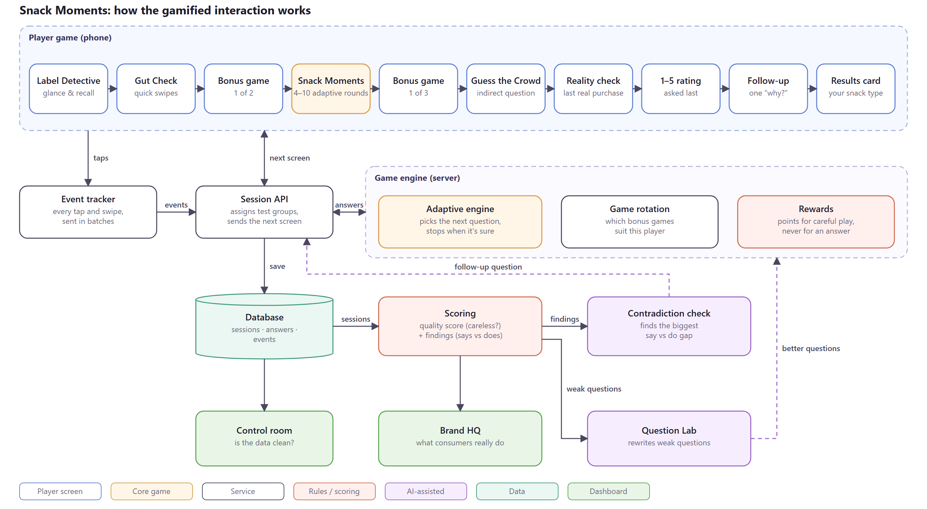
How the gamified interaction works (editable version: gamified-interaction-architecture.drawio)

What behavioural insight it captures
The game is designed to show what people do when protein has a cost, not what they say about it. From the same three minutes of play it captures:
- What protein is really worth: how many extra rupees per gram of protein each person will pay, and how that changes between moments (at the desk, after the gym, late at night).
- What drives each person: whether their choices are led by price, taste or protein, or switch depending on the moment.
- The say vs do gap: how far the 1–5 rating sits from what their choices show, and, from the follow-up question, why (price, taste, or just not hungry).
- What people notice: whether protein is even seen on a pack, compared with price.
Together this answers the question the two surveys couldn't: whether people who say protein matters actually pay for it, when they do, and what stops them when they don't.

CHALLENGE 1 · PART B: BEHAVIOURAL TRACKING AND RESPONSE INTELLIGENCE
APPROACH NOTES

My thinking process
How I worked through each Part B question, in the order the brief asks them.

Hot Takes challenge: my notes (Part B)
My first notes on how I plan to track behaviour in the background, and how I'd use it to judge answer quality and engagement.

Part B: Behavioural tracking and response intelligence

Where I'm starting
What people tell us and what they do are often different, and the gap is useful. So I want the game to quietly record how people play: how long they take, where they tap, what they change, and when they leave. From this I want to answer two separate questions. First, is this answer careless? Second, is this answer honest, even if it doesn't match what the person said? I think mixing these up is the biggest mistake to avoid. Someone who says protein matters but keeps picking chips isn't a bad player. That gap is the insight the brand wants. So careless answering should lower a quality score, but a contradiction should become a finding. I also want one firm rule from the start: nobody gets blocked automatically. The system flags, and a person decides.

1. Response quality and authenticity
Whether responses appear random, patterned or inconsistent.
For random answers, I plan to show one question again later with the cards in a different order, and to sometimes add an “overpriced twin”, the same snack at a higher price. A careful player keeps their answer on the repeat and never picks the twin. I can also check how well all of a player's choices fit one steady preference; if they fit no better than chance, the answers are probably random. For patterns, the cards are shuffled every time, so if someone still taps the same spot on screen, it shows. I'd also look for rhythms, like always top, middle, bottom. For inconsistency, I'd look for choices that make no sense together, like paying more for less protein in the same moment.
Whether users are repeatedly selecting socially desirable answers.
I can't ask people directly whether they're trying to look good, so I compare answers that should agree. The 1–5 rating comes at the very end, so I can compare it with the choices they made. I can also compare their quick gut swipes with their slower choices, what they bid for a protein bar with what their choices suggest it's worth, and what they guess other people pick with what they pick themselves. If someone always leans towards the “healthy” answer when it's free but not when it costs something, that's the signal. I'd treat this as a finding about the person, not as a penalty, and ask one short follow-up question to learn why.
Whether responses across related questions show meaningful consistency.
I want related questions to check each other. The same moment can come back with different prices. The snacks someone picks one by one can be compared with what they keep when their weekly budget is cut. The bar they design can be compared with the snacks they actually choose. And when someone maps their week, the moments should roughly add up to the total they give. One thing I need to be careful about: different answers in different moments aren't always inconsistent. Choosing protein after the gym but chips at 11pm is a real pattern, not noise.
Whether users are rushing through questions without engaging.
A fixed time limit doesn't work, because some questions are harder than others and some people are just faster. So for every question I'd work out an expected time from how much there is to read, how hard the choice is, and how fast this player usually is. An answer much faster than that, for example under about a third of the expected time, counts as rushed. I'd also check whether people slow down when the choice gets hard. Real people usually do; someone who isn't thinking answers every question at the same speed. In the quick swipe games speed is fine, but there's still a limit below which nobody can read the card.
Whether there are suspicious response patterns across multiple sessions.
Some problems only show up across sessions. I'd look for one phone being used by many “different” players, groups of sessions with exactly the same answers in the same order, and sudden rushes of new players in one hour, which often means a link shared just to farm rewards. Over time I'd also keep a simple trust level per player across studies, so a player with a history of careful answers counts a bit more.
In practice, every finished session gets a quality score from 0 to 100, built only from the careless signs above. I'd group players into high, medium and low quality. Low quality needs at least two strong signs, because one slip can happen to anyone. High quality counts fully in the results, medium counts less, and low is left out until a person checks it. For the first few weeks someone on the team reviews the flagged sessions by hand, and their decisions are saved so the score can be improved later.

2. Engagement and gamification effectiveness
Time spent on individual questions and games.
I'd record the time for every answer and every game, but I wouldn't read raw time on its own. The useful number is time compared with what the question needs. So for each game I'd look at the typical time, and for each player whether they take longer on harder choices.
Completion rates and drop-off points.
I'd build a simple funnel: how many people start, and how many are still there after each step. This shows exactly where people quit. Inside the adaptive rounds, I'd also look at which question they quit on, because a confusing or tiring question shows up as a spike in quits.
Interaction patterns and changes in behaviour across game formats.
Each game has its own signs of engagement: how many details someone uncovers before choosing, how often they change their mind, how fast they swipe, how they spend a budget. I'd compare the same player across formats, for example two-card versus three-card choices, to see if the format changes their answers. I'd also watch for tiredness: if rushing goes up in the later questions, the game is too long.
Whether users are actively engaging with the game mechanics.
A player who is engaged uses the game: they uncover details, adjust their crowd guess, rebalance their budget, or redesign their bar when costs go up. A player who isn't just taps the first option and moves on. So for each mechanic I'd track whether it was actually used, not just whether the screen was passed.
Which game formats drive better completion and response quality.
For every game I'd show three numbers side by side: how many people finish it, how long it typically takes, and how many answers are rushed. To be fair to each game, I'd calculate time and rushing only on careful players, so a game isn't blamed for careless people. A game that people enjoy but race through is fun but not useful, and that's the kind I'd want to fix first.
Whether rewards, challenges and interactions influence participation.
To know if rewards change behaviour, I need a fair test, not a guess. So I'd randomly give some players a bigger mystery gift and others a smaller one, and compare how carefully they play afterwards. The same idea works for other parts of the game, like whether showing protein or taste first on the cards changes choices. I also want to make sure points only reward careful play and good crowd guesses, never a particular answer, and to check that the people earning the most points aren't the ones answering worst.
In practice, all of this lives in one control room for the research team, with the funnel, timing, game comparison and reward tests each in its own view. Because the reward and wording tests are random, any difference between the groups is caused by the change, so the team can act on it with confidence.

3. Backend tracking and intelligence
What data points would you capture at the backend to measure the above?
Events and behavioural data to track.
I want to record what players do, not just what they answer. So the phone keeps a quiet log of every action and sends it to the server in small batches, so the game never slows down. When a session starts, I note which test group the player is in. When a question appears, I note how long it should take to read. Then I record how they behave on it: when they first touch the screen, which options they look at, whether they change their mind or cancel a tap, and when they finally confirm.
In the other games I record the swipes, which hidden details they open, what they add to or remove from the shelf, how they cut the budget, and how they move their crowd guess. If they type an answer, I note how long it took, whether they pasted it and how much they deleted. I also want to know when they leave the app and come back, when a hidden check or a reward is shown, and whether they finish the game or where they stop. To spot the same person playing many times, I'd keep a code for each phone and a scrambled version of the internet address, but never anything that tells me who the person is.
Metrics and KPIs to calculate.
- Data quality: share of usable answers, quality score spread, share of rushed answers, repeat agreement, same-spot tapping.
- Engagement: completion rate, drop-off per step, typical time per game, switching to other apps.
- Insight: the say vs do gap, how often protein wins in each moment, and what protein is worth per gram.
- Games and rewards: completion and quality per format, and the result of each reward test.
- Business: cost per usable response, which tells us if all of this is worth it.
How you would flag potentially low-quality or suspicious responses.
I don't want one mistake to label someone as a bad player, because anyone can tap too fast once. So I'd look at all the warning signs together and give each one a weight. Some signs matter a lot, like answering faster than anyone could read, always tapping the same spot, or picking the more expensive copy of the same snack. Others are small, like a slightly odd tapping rhythm, and I'd only count those if a bigger sign shows up too. All of this adds up to a score out of 100. If someone shows two or more big signs, I'd mark them as low quality and keep their answers out of the results, but I wouldn't block them; someone on the team would look at it first. Every flag should come with a simple reason, like “answered 7 of 9 questions faster than anyone could read them”, so whoever checks it understands it straight away. I'd also work out the score on our server rather than on the phone, so nobody can mess with it.
How AI could help identify patterns across responses and sessions.
I see AI as an assistant here, not the judge. The numbers and the flags should come from clear rules and statistics. AI can then help in three ways. It can explain a flagged session in plain words, so the reviewer doesn't have to read raw events. It can look across many sessions and point out groups that behave alike, which is how a bot ring or a shared answer key shows up. And it can read the short written answers to spot pasted or meaningless text and to sum up the reasons people give. I'd only send AI summarised data, never personal details.
How you would distinguish genuine engagement from someone simply trying to complete a game quickly.
I don't think speed alone tells me much, because some people just know what they like. So I look at speed and consistency together. If someone is fast but their choices still make sense, and they give the same answer when a question comes back, I think they're simply decisive. If someone is fast and their choices jump around, they're probably just trying to finish. I also expect real players to slow down when a choice gets harder and to actually use the game, like opening the hidden details before they pick. Someone rushing through takes the same time on every question, taps the same spot every time, and falls for the hidden checks.
In practice, the phone only collects events; all scoring happens on the server and is versioned. Raw events are kept separately from the scores, so if we improve the formula later we can score old sessions again. I'd start with simple, explainable rules, and once the team has reviewed enough sessions, use their decisions to tune the weights.

Open questions, and what comes next
On the thresholds: the cut-offs, like “a third of the expected time”, are my starting guesses. I need real players to tune them, and I'd check how many honest people get flagged by mistake.
On privacy: players should know that how they play is recorded. I'd keep tracking to what we need, hash anything that could identify a device, and agree the consent wording with the legal team.
On cost: tracking every tap creates a lot of data. I'd keep raw events for a set period and keep the summaries longer.
Next steps: run a pilot, have the team review the flagged sessions, compare their decisions with the score, and adjust the weights before scaling up.

CHALLENGE 1 · PART B: BEHAVIOURAL TRACKING AND RESPONSE INTELLIGENCE
SUBMISSION

Tracking and response intelligence proposal
The five items the brief asks for. Where a topic is already answered in the approach notes, the proposal says so in one line.

Hot Takes challenge 1, Part B: proposal
Behavioural tracking and response intelligence. The thinking behind each choice is in my Part B notes; this is the proposal itself. Everything below is built and running in the Snack Moments prototype, unless I say it's future work.

1. Suggested tracking framework
I split the system into four steps. The browser only records what the player does. The server turns those events into scores and findings. The scores decide how much each answer counts and what the game does next. And the team's reviews and our random tests feed back in, so the engine gets better over time.
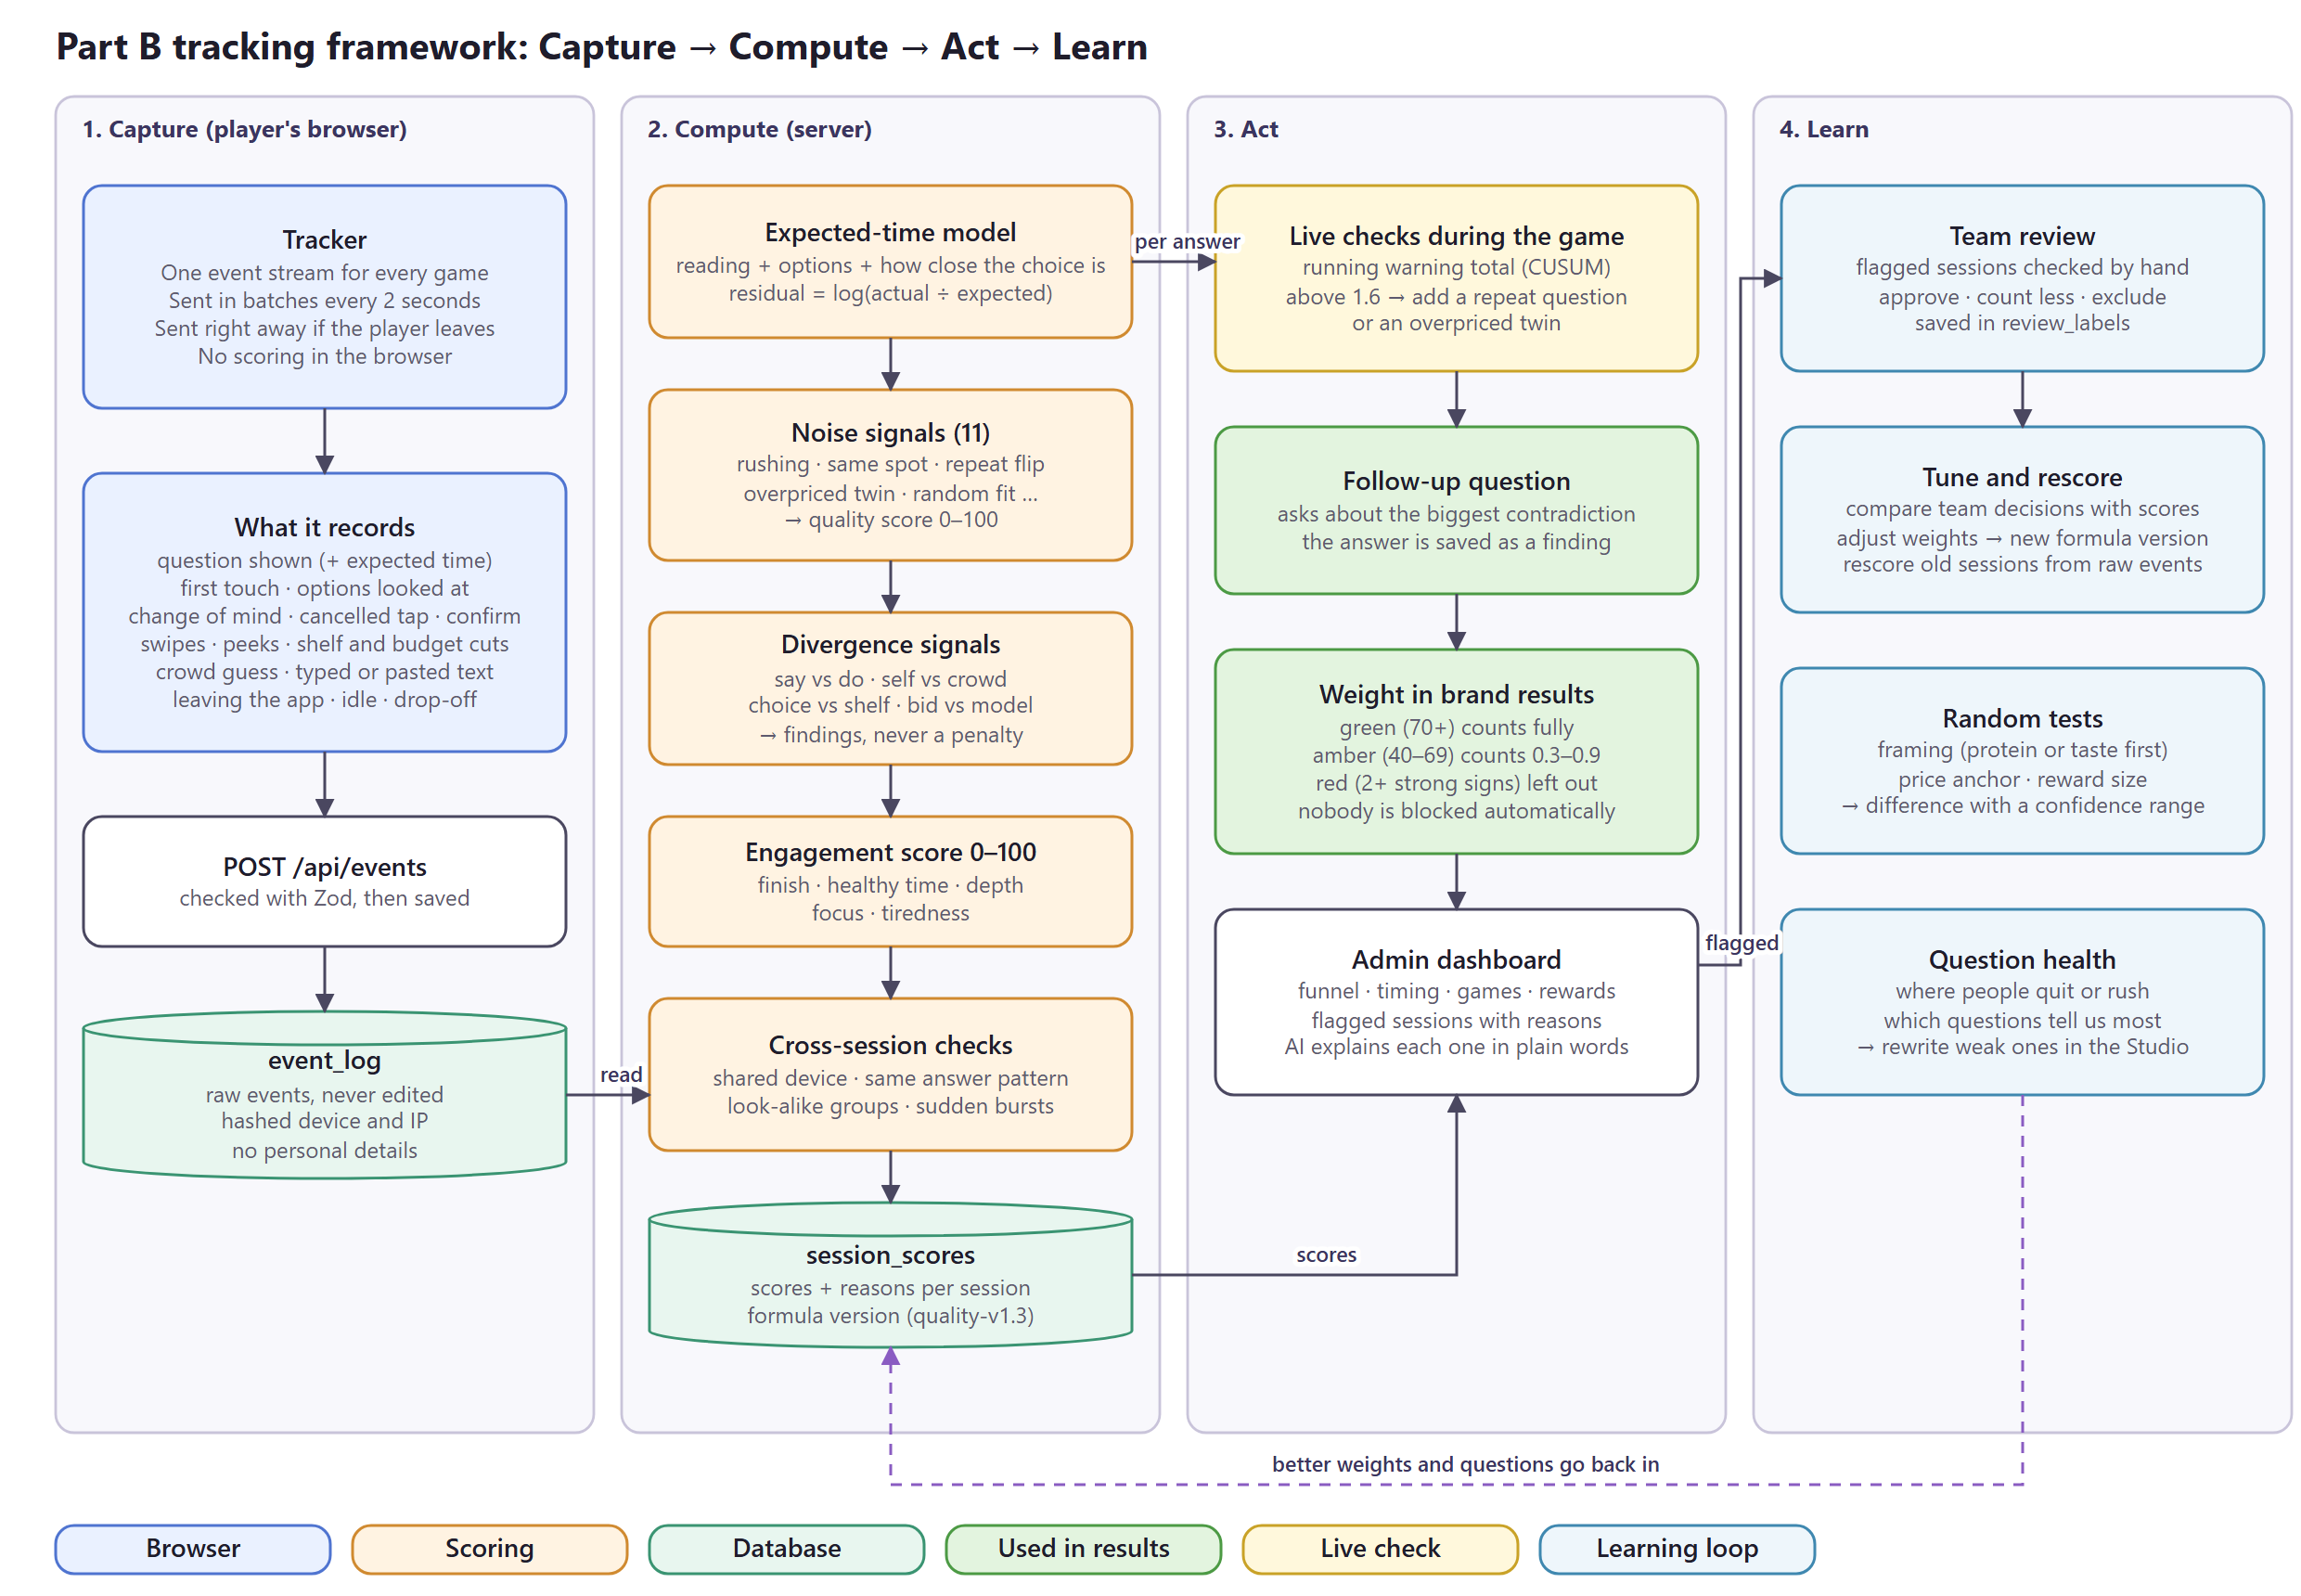
Part B tracking framework (editable: part-b-tracking-framework.drawio)
The rules I built it on:
- The browser never scores. It only sends events. All scoring happens on the server, so nobody can change their own score.
- Raw events are never edited. Scores are saved separately with a formula version (now quality-v1.3), so when the formula improves, old sessions can be scored again.
- Careless and contradictory are two different things. Careless signs lower the quality score. A gap between what someone says and does is a finding for the brand, never a penalty.
- Nobody is blocked automatically. The system flags with a reason in plain words, and a person decides.

2. Events and metrics I'd capture
Why each event matters is in section 3 of my Part B notes. This is the actual list the prototype records. Every game uses the same event stream, sent in batches every 2 seconds and right away if the player leaves the page.
Event | When it fires | What we keep
Choice rounds
item_shown | A question appears | question, round, expected time, test group
first_touch | First tap on the screen | time since the question appeared
option_focus | Player looks at an option | which option
option_change, tap_cancel | Changes their mind or cancels a tap | from and to
option_select, confirm | Picks and confirms | option, screen position, time taken
Other games
gut_swipe | Each swipe in Gut Check | snack, left or right, milliseconds
peek_reveal | Opens a hidden detail in Peek & Pick | which detail, in what order
label_peek_start / end, label_answer | Label Detective | how long they looked, their answer
shelf_add, shelf_remove, squeeze_start, squeeze_remove | Stock the Shelf and the budget cut | snack, price, what was cut first
bar_set, bar_squeeze_start, bar_cut | Build-a-Bar | points given to protein, taste and price
bid_locked | Bid It | moment and bid
crowd_adjust | Guess the Crowd | each move of the guess
week_overall, week_set | My Snack Week | whole-week total and each moment
text_paste | Typed answer | pasted or not, typing time, deletes
Whole session
visibility_hidden / visible | Leaves or comes back to the app | time
idle | No activity for 20 seconds | time since the last tap

Each session also stores a hashed device code, a hashed internet address, and the random test groups the player is in (framing and price anchor). Nothing that tells us who the person is.
How each metric is calculated
The list of metrics is in section 3 of my Part B notes. This is how I calculate them:
Metric | How it's calculated
Usable answers | Share of finished sessions in the green or amber band
Rushed answers | Share of answers made in under 35% of their expected time
Repeat agreement | Share of repeat questions answered the same way as the first time
Completion and drop-off | Sessions that reach each step ÷ sessions that started; also which question people quit on
Typical time per game | Median time per game, worked out on careful players only so a game isn't blamed for careless ones
Say vs do gap | The 1–5 rating minus a 1–5 score worked out from their choices
What protein is worth | ₹ per gram from each player's choice model, separately for desk/gym moments and late-night moments
Random test results | Difference between the random groups, with a 95% confidence range
Cost per usable response | Total study cost ÷ the sum of response weights (needs cost data, future)

3. How I calculate the quality and engagement scores
Expected time
A fixed “too fast” limit doesn't work, because some questions are harder than others. So every question gets its own expected time, and I compare the real time with it:
expected = 0.9 s + 0.26 s per word + 0.45 s per extra option
+ up to 2.2 s when the choice is close for this player
residual = log(actual time ÷ expected time)
rushed = residual < log(0.35) // under 35% of the expected time
Quality score (0 to 100)
Every finished session starts at 100. Each careless sign has a severity from 0 to 1 and a maximum number of points it can take away. Only careless signs are used here; contradictions never are.
Sign | What it means | Max points | Type
Rushing | Share of answers under 35% of the expected time | 36 | Strong
Overpriced twin | Picked the same snack at a higher price | 25 | Strong
Same screen position | 70%+ of taps on one spot (half), 85%+ (full), even though cards are shuffled | 22 | Strong
Quick games too fast | Gut Check under 350 ms a card, or Label Detective answered in under 1 s | 22 | Strong
Repeat flip | Changed answer when the same question came back, scaled by how sure their own model was | 18 | Strong
Random fit | Their choices fit their own preference model no better than 1.05× chance | 18 | Strong
Open text | Typed answer looks pasted or meaningless | 12 | Strong
Paid more for less | Refused a cheaper protein deal after taking a pricier one, in the same moment | 10 | Strong
Tapping rhythm | Tap positions repeat in a fixed cycle, like 1-2-3-1-2-3 | 8 | Weak
Flat timing | Hard choices take no longer than easy ones | 8 | Weak
Snack week total | Moments add up to far more or less than the whole-week answer | 6 | Weak

strong = number of strong signs with severity >= 0.5
penalty = sum(max points × severity) // weak signs only count if strong > 0
score = 100 − penalty
band = green if score >= 70, amber if 40–69, red if < 40
(red needs 2+ strong signs, otherwise it stays amber)
weight = green 1 · amber 0.3 to 0.9 (rises with the score) · red 0
The weight is how much the session counts in brand results. Red sessions are left out until someone on the team checks them; they are never deleted or blocked.
Engagement score (0 to 100)
Part | Points | How it's earned
Finished | 35 | Full points for finishing; otherwise 3 per answered question, up to 25
Healthy time | 25 | Share of answers between 45% and 4× the expected time (not rushed, not distracted)
Depth | 15 | Options looked at plus changes of mind per question (full points at about 1.2)
Focus | 15 | Loses points each time the player leaves the app; 0 after 3 times
Tiredness | 10 | 10 if they don't speed up in later questions, 5 if a little, 0 if a lot
Trust across studies
Each player has a trust level that builds up over studies. It starts at 0.67 and moves towards their usual quality. Older studies slowly count less, so a player can recover from one bad session:
after each study: a = a × 0.9 + weight b = b × 0.9 + (1 − weight)
trust = a ÷ (a + b) // starts at a = 2, b = 1

4. How I'd identify response bias and suspicious behaviour
Bias: compare answers that should agree
I can't ask people if they're trying to look good, so I compare two answers to the same question that come from different games. These gaps are saved as findings and never lower the quality score:
Gap | What it compares
Say vs do | The 1–5 rating, asked last, with what their choices show
Self vs crowd | How much they say protein matters to them with what they guess others pick
Choice vs shelf | Protein in single choices with protein in the weekly basket
Gut vs choice | Quick swipes on protein snacks with slower, priced choices
Bid vs model | What they bid for a protein bar with what their choices say it's worth
Design vs choice | How much protein their designed bar has with how much protein matters in their choices
Moment gap | ₹ per gram at the desk or gym with ₹ per gram late at night
Budget cut | Whether protein snacks are the first thing cut when the budget drops

The biggest gap for each player triggers one follow-up question at the end, with four possible reasons (for example price, taste, the moment, or not available). Their answer is saved as a finding, so the brand learns why, not just that.
Suspicious behaviour inside a session
While the game runs, every answer adds warning points: +0.9 if it was rushed (under 35% of the expected time), +0.4 if it was quick (under 55%), +0.35 if it's on the same spot as the last tap, and +0.35 if the pick is very surprising for this player. A running total (CUSUM) adds these and subtracts 0.5 each answer. If it goes above 1.6, the next question is a check: a repeat question or an overpriced twin. Every session also gets one of each anyway, so careful players are checked too.
Suspicious behaviour across sessions
Check | How it works
Shared device | The same hashed device code used by more than one player
Same answer pattern | Sessions with the exact same order of tap positions and swipes
Look-alike groups | Sessions grouped by behaviour (speed, tap spread, model fit, swipe speed, leaving the app, length) using k-means; the 5% furthest from any group are marked as outliers
Sudden bursts | An hour with at least 4× the usual number of new sessions

The role of AI and how I tell a decisive player from a rushing one are in section 3 of my Part B notes. In short, AI explains flagged sessions and checks typed answers, but it never sets a score, and speed only counts as careless when the choices also stop making sense.

5. How I'd use this data to keep improving the research engine
Loop | What happens | In the prototype
Team review | Reviewers mark flagged sessions as approve, count less or exclude. Their decisions are compared with the score to tune the weights and cut-offs | Labels built; tuning needs real players
Rescoring | A new formula gets a new version, and old sessions are scored again from the raw events | Built
Random tests | Players are randomly shown protein-first or taste-first cards, and different starting prices. The difference between groups is shown with a confidence range, so the team knows the change caused it | Built; reward-size test is next
Question health | For each question: where people quit, how often it's rushed, and how much it tells us. Weak questions are rewritten in the Studio, where one AI model rewrites and another reviews for bias | Built
Smarter question order | The next question is the one we'd learn the most from for this player, and the game stops once we know enough (4 to 10 rounds) | Built
Fair game comparison | Optional games are rotated, and results are re-weighted (inverse probability weighting) so the rotation doesn't bias them | Built

Future work: once the team has reviewed enough real sessions, learn the weights from their decisions instead of setting them by hand, and tune cut-offs like “35% of the expected time” on real players, checking how many honest people get flagged by mistake.

CHALLENGE 2 · TRUSTWORTHY ONBOARDING AND VERIFICATION
APPROACH NOTES

My thinking process
How I worked through each Challenge 2 question (sections 1 to 5), in the order the brief asks them.

Hot Takes challenge 2: my notes
My first notes on how I plan to verify players without scaring them away.

1. Verification strategy
Would you recommend Aadhaar-based verification or an alternative?
I wouldn't start with Aadhaar. Hot Takes is still a new name, and asking a stranger for their Aadhaar on the first day is the quickest way to lose them. The law also says a private company can't force anyone to verify with Aadhaar, so I'd have to offer another option anyway. So I plan to use DigiLocker instead. Most people already know it from government services, the consent screen belongs to the government and not to us, and the user picks which document to share, whether that's Aadhaar, a driving licence or PAN. The new data protection rules also name DigiLocker as a trusted way to check age. From that one step I get their real date of birth and a unique DigiLocker ID. The birth date tells me they're over 18, and the ID makes sure one person can only have one account.
What other identity, age and uniqueness verification methods could we consider?
I looked at a few others, and most of them are either too heavy for a new brand or too easy to get around:
- The new Aadhaar app QR can share just “over 18” without showing the birth date, which is very private. But we'd have to register with UIDAI first, so I'd keep it for later.
- PAN check gives the birth date, but not everyone has a PAN.
- Selfie liveness and face matching are strong for proving a real person and catching duplicates, but storing face data is complex and it scares people off.
- Guessing age from a selfie is cheap, but unreliable for someone close to 18.
- Mobile OTP adds a step and proves little, because SIMs are cheap.
- Google sign-in and device fingerprinting are easy to get around, since anyone can make a new Google account in a minute, and families share phones. They work as warning signs but not as rules.
Could a combination of different verification methods achieve the same objectives?
Yes, but I want as few pieces as possible. DigiLocker carries the hard checks, and everything else just supports it:
- Real person: DigiLocker shows there's a real government document behind the account.
- 18+: I work it out from the birth date.
- One account per person: one DigiLocker ID can only be linked to one Hot Takes account.
- Genuine data for brands: only answers from verified players go into brand results.
Google sign-in is only for logging in. Device and behaviour signals stay in the background as warning signs, and over time the response-quality checks from Part 4 do the rest. The gap I know about is someone using a family member's DigiLocker. No ID check really stops that, which is why behaviour matters later.
What would you recommend balancing verification reliability, cost, privacy and user friction?
I plan to ask for nothing at the start. People can try sample questions first and get a feel for the app before we ask for anything. I'd only ask for DigiLocker once their answers are about to count in brand data, or when they claim their first reward, because by then they trust us and have a reason to finish.
On cost, DigiLocker doesn't publish a price for companies, but through a provider like Message Central a check costs ₹2.49 and is only charged when it succeeds. That's about ₹2,500 for every 1,000 verified players, and we only pay for people who get that far. On privacy, I store only a scrambled DigiLocker ID, a “verified” flag and their age or age band. I delete the birth date and never keep the document. On friction, it's one step at the right moment. On reliability, the main gap is the family-member case, and behaviour checks cover that.
Suggestion: if rewards are paid into a bank account, I'd also check that the bank account name matches the DigiLocker name. That way a second account made with someone else's DigiLocker can't cash out.

2. Consumer onboarding experience
How would you get someone from app download to signup and their first completed game?
I plan to let people play before they sign up. The app opens straight into a short sample game, so in the first minute they're tapping snack cards, not filling in a form. At the end they see their result card and the points they've earned, and only then do I ask them to save those points with one-tap Google sign-in. After that I ask just two quick questions, their age and city, and take them straight into their first real study. Anything else, like gender or habits, I'd ask later inside the games. So the order is: play, enjoy it, sign in to keep what they earned, then play for real.
How would you address hesitation around sharing identity information with a relatively new platform?
I think the best answer is to not ask until they trust us. By the time I ask for DigiLocker, they've played a few games and have points waiting, so they already know what Hot Takes is. When I do ask, I'll be very clear about what we get and what we don't. We get their name, date of birth and a DigiLocker ID. We never see their Aadhaar number, address or documents. It also helps that the consent screen belongs to the government, not to us. And I'd keep the first reward small and quick to reach, because getting paid once builds more trust than any message.
At what point should verification happen?
Not at signup. I plan to ask for DigiLocker at whichever comes first: when they try to claim their first reward, or when their answers are about to go to a brand. Until then they can keep playing, and I hold their answers. For example, if Riya plays three studies before verifying, her answers wait to one side, marked as not verified, and brands can't see them. When she passes DigiLocker, all three move into the brand data. If she never verifies, or turns out to be under 18, they're deleted. This way nobody is pushed to verify early, and no good data is thrown away.
How would you communicate why verification is required and how consumer information is protected?
One simple screen, at the moment I ask, with three lines. Why: brands pay for real opinions from real adults, and this is what lets us pay you. What we see: your name, age and a DigiLocker ID, and nothing else. What we keep: only that you're verified and your age; your date of birth is deleted and we never store documents. Under that, a link to a plain-language privacy page and an option to delete their account and data at any time.
How would you minimise drop-offs during onboarding?
Most drop-off comes from asking too much too early, so I plan to remove every step I can before the first game: no form, no OTP and no password. Sign-in is one tap. I'd also keep the app light, offer Hindi and other regional languages, and measure drop-off at every step so I know exactly where people leave.
DigiLocker is the step where I expect most people to drop, so I want a clear plan for each way it can go wrong:
- They leave halfway: their games and points stay safe. The next time they open the app, a small banner says their reward is waiting and it takes a minute to finish. I'd also remind them by email, since we already have it from Google sign-in, and on WhatsApp if they've agreed to it. I'd ask for their WhatsApp number only at that moment, as an option, not at signup. One reminder after a day and one after three days, and then I stop, because more than that feels like nagging.
- They tap “Deny”: I show them again exactly what we see and let them try whenever they want.
- They don't have DigiLocker: I give them a short guide to create one with their mobile number, and send the same reminders.
- DigiLocker is down: I don't count it as a failure, I just remind them later.
- They're under 18: I delete their held answers and lock the account from verifying again, so they can't try with a parent's DigiLocker.
- Their DigiLocker is already linked to another account: I show the masked email of that account so they can sign in there. If they say it isn't theirs, they can tap “Ask for help”, and someone on the team reviews it within two working days.

3. Engineering and system architecture
Hot Takes runs in the browser, on desktop and in Chrome or Safari on phones, so everything below is built for the web. My main rule is that the browser never decides anything. It never says “I'm verified” or “I'm 18”; the server works all of that out and the browser only holds a signed session token.
Third-party verification APIs and integrations.
These are the integrations I plan to use:
Purpose | Integration | Why
Login | Google Sign-In (Apple on iPhone) | One tap. I key the account on Google's stable user ID (“sub”), not the email, because emails can change.
Identity, age, duplicates | DigiLocker through an aggregator | One consent gives me the birth date and a unique DigiLocker ID.
Bot check | Cloudflare Turnstile or reCAPTCHA Enterprise | Invisible check at sign-in and when DigiLocker starts, to stop scripts.
Device signal | Browser fingerprinting (FingerprintJS) | Helps spot many accounts on one device. A warning sign only.
Reminders | Email (Amazon SES), WhatsApp Business API via a provider such as Gupshup | Email we already have from Google. WhatsApp only if the player agrees.
Push | Web Push (Firebase Cloud Messaging) | Works on Chrome. On iPhone Safari only if the app is added to the home screen, which is why email and WhatsApp matter.

Direct DigiLocker or an aggregator
Going direct through DigiLocker's partner portal is the cheapest per check, but approval takes time and we'd build and maintain everything ourselves. An aggregator like Message Central, Cashfree, HyperVerge or Digio costs ₹2.49 per successful check, goes live in days, and comes with ready SDKs and status notifications. I plan to launch on an aggregator, but behind an adapter. All our code talks to our own VerificationProvider interface, with start() and getResult(), and never to the vendor directly. That way I can switch to direct DigiLocker later by writing one new adapter, and I can keep a second aggregator as a fallback. If the main one starts failing, a circuit breaker moves traffic to the fallback automatically.
How the flow works
- 1. The browser calls POST /verification/start.
- 2. The server creates a verification session with a random “state” value, which stops forged callbacks, a PKCE code verifier, which stops a stolen code from being used, and a 30-minute expiry. Both are tied to the user's secure session cookie. The server returns the DigiLocker URL.
- 3. The browser does a normal full-page redirect to DigiLocker, so the user sees the real government page and we never see what they type.
- 4. The user logs in to DigiLocker with its own OTP, ticks what to share and taps Allow. DigiLocker sends them back to our HTTPS callback with a one-time code and the state.
- 5. Our server, not the browser, checks the state matches, swaps the code for a token server-to-server, so the secret key never reaches the browser, and fetches the user details.
- 6. The server works out what it needs and throws the raw data away straight away.
If the user closes the tab after tapping Allow, the callback never arrives. So I don't rely on it alone. The aggregator also tells our server directly through a webhook, and the server marks the session as done. When the user comes back, the server already knows.
Making it reliable and secure
- Webhooks: I check the provider's HMAC signature and timestamp on every call, reject replays, and only accept calls from the provider's IP addresses.
- Retries: a DigiLocker code works only once, so I never blindly retry the token swap. If it fails, the flow restarts. Fetching user details is safe to retry with backoff.
- Timeouts and failover: if the provider's error rate jumps, traffic moves to the fallback provider. If both are down, the user sees “DigiLocker is busy” and the reminders take over.
- Secrets: API keys live in a secrets manager (AWS Secrets Manager or GCP Secret Manager), never in code or in the browser.
- Legal: under the DPDP Act the aggregator is our data processor. The contract needs data kept in India, deletion within a fixed time, no reuse, and breach notification. I'd also ask only for the minimum scope: user details, and not the full Aadhaar XML with address and photo.
Identity and age verification.
When the user taps Allow, DigiLocker's user details give me a DigiLocker ID that's unique per account, their name, birth date and gender, and an eAadhaar flag that says whether the account is linked to Aadhaar.
Which data I trust
DigiLocker holds two kinds of documents. Issued documents come straight from the department that issued them, like UIDAI for Aadhaar, the transport department for a licence or Income Tax for PAN, and they're digitally signed. Uploaded documents are files the user put there themselves, and anyone can upload anything, so I never accept them. That gives me three cases:
- eAadhaar flag is Y: the birth date in the profile came from Aadhaar, so I accept it. Most people go this way, in one step.
- eAadhaar flag is missing: on the same DigiLocker consent screen, the user ticks their issued PAN or driving licence, which is already in their DigiLocker. They never type it into our app or upload a photo. I read the birth date from that document's signed data and check the issuer's signature. The screen says: “Your DigiLocker isn't linked to Aadhaar, so we need one other ID to confirm your age. Pick your PAN or driving licence on the next screen. We only read your birth year and never keep the document.”
- Neither: they can't verify yet, and they get the guide from Q2.
Working out the age
- Server only, in Indian time. The browser never tells me someone's age.
- Proper calculation: subtract the years, then take one off if this year's birthday hasn't come yet. Someone born on 11 November 2008 is 17 today and 18 tomorrow.
- Different formats: dates come as DDMMYYYY or DD-MM-YYYY depending on the source, so I normalise them first.
- Year-only dates: some older Aadhaar records only have a year of birth. To be safe I assume 31 December of that year, so someone recorded as 2008 counts as 18 only in 2027. It's strict, but it never lets a minor through.
- Typed age vs DigiLocker: when we need their real age, I compare what they typed with DigiLocker, and DigiLocker always wins. If the two are more than a year apart, I log it as a small signal for the quality score in Part 4.
What I keep and what I throw away
I keep only that they're verified, their year of birth, which keeps their age band right as years pass, the method used (eAadhaar, licence or PAN) and the date. The full birth date, name, gender and any document are used in memory and dropped at once, and never written to disk or logs. I don't need the name at all, unless we later add the bank name check, and then I'd keep only a scrambled version.
Real person and re-checks
To log in to DigiLocker, the user has to pass an OTP sent to the mobile on their account. So at that moment a real person with a real government ID was in control, which is enough without face checks. If an account looks suspicious later, I can ask for DigiLocker again, and the DigiLocker ID that comes back must match the one I stored. If it doesn't, someone else is using the account.
Duplicate account detection.
Key | How it's stored | On a match
DigiLocker ID | HMAC-SHA256 with a secret key kept in a key vault (KMS) | Blocked, enforced by the database
PAN or licence number (only for the non-Aadhaar route) | Same HMAC, kept per document type | Blocked
Name + birth date | HMAC of the cleaned-up name and full birth date | Flagged for review, never blocked
Google account (“sub”) | As is | Already one per account

For most people the DigiLocker ID is the only key, and I never see their Aadhaar number. The document number only exists for the few people on the PAN or licence route, because it comes inside the document I read their birth date from. I keep it because someone without Aadhaar linked might make a second DigiLocker account with another mobile number and pull the same PAN into it. Whether DigiLocker allows that is something I'd confirm with them or the aggregator.
I use HMAC and not a plain hash so that if our database ever leaked, nobody could match these values against other lists without the secret key, which lives in the key vault and not in the database. The database itself enforces the rule: the DigiLocker column has a unique index, so if two sign-ups with the same identity arrive at the same moment, only one gets through. On a match, I don't create anything new. The user sees the masked email of the existing account, like h***@gmail.com, and the attempt is logged.
Database architecture and identity mapping.
My main idea here is that identity data lives apart from research data, and brands only ever see a stand-in ID. I'd use Postgres, with two separate databases:
APP DATABASE IDENTITY VAULT (separate, locked down)
users identities
user_id, google_sub, identity_id, user_id,
email (encrypted), status digilocker_hmac (UNIQUE),
verification_sessions doc_hmac per type (UNIQUE),
id, user_id, provider, state, name_dob_hmac (index),
pkce_verifier (encrypted), birth_year, method, verified_at,
status, reason, attempts, key_version
created_at, expires_at participant_map
verification_events (append-only) user_id -> participant_id (per brand)
responses tombstones (deleted identities)
participant_id, study_id, answer,
hold_state: held / released / deleted
devices (fingerprint_hash, user_id)
review_cases
- Stand-in IDs: each player gets a different participant_id for each brand. Brands can't see who the person is, and two brands can't join their data to follow one player across studies. Only the vault knows which user sits behind a participant_id.
- Held answers: every response has a hold_state. Brand exports only read “released”. When a player is verified, all their held answers flip to released together.
- Access: only the verification service can reach the vault, with its own database user. The rest of the app can only ask “is this user verified, and what's their age band?”
- Region: everything stays in an Indian region, like AWS Mumbai.
Secure handling and storage of sensitive information.
- Raw data never touches disk. The server reads DigiLocker's reply in memory, takes the age and the hashes, and drops the rest. Our logging only writes fields on an approved list, so a name or birth date can't slip into a log by mistake.
- Encryption: TLS for everything in transit, encrypted disks, and field-level encryption for email and phone with keys in KMS, so even a database admin can't read them in plain text.
- Secrets and key rotation: API keys and the HMAC key sit in a secrets manager and are rotated. Every hash records its key_version, so I can move to a new key without breaking the duplicate checks.
- Least access: staff get access only when they need it, for a limited time, and every access is logged. No personal data goes into the analytics warehouse, only stand-in IDs and age bands.
- Keeping and deleting: verification sessions are deleted after 90 days, and held answers after 90 days if the player never verifies. When someone deletes their account, everything goes except the DigiLocker hash, which moves to a tombstone list for 12 months. Without it, someone could delete their account and sign up again to claim the first reward twice. I'd say this plainly in the privacy policy.
- Consent records: I store what the user agreed to, when, and which version of the notice they saw, because the DPDP Act needs us to prove consent.
- Breaches and testing: a ready plan to tell the Data Protection Board and affected users quickly, and regular security testing.
Verification status management.
I'd keep one status machine, and only the server can change it:
unverified -> pending -> verified
|---> failed (reason) --> pending (retry)
|---> expired --> pending (retry)
|---> under_age [final]
|---> duplicate --> review
'---> review --> verified / failed
verified --> revoked (a later re-check fails or fraud is confirmed)
- One function makes every change. It checks the move is allowed, uses a version number so two updates can't clash, and writes a row to verification_events every time, so I have the full history.
- Callback and webhook can both arrive, in any order. Handling is idempotent: if the session is already verified, the second message does nothing.
- Expiry job: every 5 minutes a small job marks pending sessions older than 30 minutes as expired, which starts the reminders.
- Releasing held answers: when a player becomes verified, the same transaction writes a “release answers” task to an outbox table. A worker picks it up and releases them. If the worker crashes, the task is still there and runs again, so no answers get stuck on hold.
Failed verification, retry and abandoned verification scenarios.
Reason code | Cause | Retry? | What I do
user_denied | Tapped Deny | Yes | Show what we see, Try again
no_account | No DigiLocker | Yes | Guide, then reminders
no_trusted_doc | No eAadhaar and no issued PAN or licence | Yes | Explain how to link Aadhaar or fetch a licence in DigiLocker
provider_error | Aggregator or DigiLocker down | Automatic | Switch to the fallback provider. If both are down, “busy” and remind later. Not counted as an attempt
expired | Left midway | Yes | Banner, plus email and WhatsApp on day 1 and day 3, cancelled the moment they verify
signature_invalid | Document signature doesn't check out | No | Treat as tampering and send to review
under_age | Under 18 | Never | Delete held answers and lock the account
duplicate_identity | ID already linked to another account | Through review | Show the masked account and Ask for help

Each account and each device gets up to 5 attempts a day. Normal users never hit this, but it stops someone cycling through family members' DigiLockers. Reminders are scheduled jobs tied to the session and cancelled automatically once the player is verified, so nobody gets “please verify” after they've done it.
Preventing users from bypassing verification through multiple accounts or devices.
The key point is that extra accounts are worthless without their own real DigiLocker identity. Rewards and brand data only unlock after verification, and one identity unlocks one account. So making ten Google accounts just gives you ten accounts that can't earn anything. Around that I'd add a lighter layer of signals that flag but never block:
- Bots: Turnstile or reCAPTCHA at sign-in and when DigiLocker starts.
- Devices: a browser fingerprint. Many accounts on one device is only a flag, because families share phones.
- Network: IPs from data centres, VPNs and proxies, and bursts of sign-ups from one IP range.
- Speed limits: accounts created per device per day, and DigiLocker attempts per device.
- Borrowed identities: the under-18 lock stops a minor switching to a parent's DigiLocker, suspicious accounts are asked to verify again and must match, and behaviour patterns from Part 4 catch the rest.
- Sold or shared accounts: changing where rewards are paid, or signing in from a new device right before a payout, triggers a fresh DigiLocker check.
- Server decides everything: the browser only holds a signed session token and never says it's verified.

4. Beyond initial verification
Could consistency across a user's responses over multiple studies help establish response reliability?
Yes, but only for things that shouldn't change. If someone tells us in one study that they're vegetarian, live alone and shop on Blinkit, and in the next study they're non-vegetarian with three kids, one of those answers is careless. So I plan to keep a small set of anchor facts, like diet, household, city and where they shop, and re-ask one of them inside a game now and then. A stable fact that keeps flipping lowers their reliability. I'd be careful with preferences, though. People really do change what they like, and someone choosing protein bars in March and chips in June isn't lying. So changing preferences stay as insights, and only contradicting facts count against them. I'd also look at how a player's own pattern holds up. If their choices in each study fit a steady preference, they're reliable. If they look random in every study, that's a pattern too.
Could behavioural patterns help identify suspicious accounts?
Yes, and I think this is where the most fraud shows up, because one person running many accounts tends to repeat themselves. I'd look at two levels:
- One account over time: getting faster and faster until they answer faster than anyone could read, only playing when the reward is high, or a sudden change in how they play right after the payout details change, which can mean the account was sold or taken over.
- Across accounts: accounts that share a device or network, play at the same times, give the same answers in the same order, tap with the same rhythm, or were all verified within minutes of each other.
I'd group accounts that look alike and send the group to a person to review, never block automatically. One shared phone in a family is normal; ten accounts with identical answers is not.
Could we develop a progressive trust or response-quality score?
Yes. I'd keep two separate numbers. Session quality is how careful one game was, which is the score from my Part B notes. Trust is how reliable this player has been over time. Trust starts neutral for a new player, grows with every good session and drops with careless ones. Recent games count more than old ones, so someone who improves isn't stuck with a bad start, and a trusted player who starts slacking drops quickly. I'd use trust in three ways:
- Brand data: answers from trusted players count fully, and answers from low-trust players count less.
- Studies and payouts: trusted players get higher-paying studies and faster payouts.
- Checks: low-trust players get a few more hidden checks.
Players see a simple level, like New, Regular or Trusted, because it motivates careful play and makes the better studies feel earned. They never see the score or how it's worked out, so they can't game it. And trust never bans anyone; it only changes weight and access.
How would you distinguish identity verification from response-quality verification?
I see them as two different questions. Identity verification asks “who are you?” It happens once through DigiLocker, the answer is yes or no, and it decides whether your answers can be used at all. Response quality asks “how carefully did you answer?” It's checked in every session, the answer is a scale, and it decides how much your answers count.
A real, verified adult can still give careless answers, and a careful player can still turn out to be using someone else's identity. So I'd keep the two separate, in separate data, run by separate parts of the system. Identity lives in the locked vault, and quality lives with the research data. There's only one link between them, and it goes one way: strong fraud signals from behaviour, like a group of identical accounts, can trigger a fresh DigiLocker check. A low quality score alone never changes someone's verification status.

5. Measuring success
What metrics would you track to understand whether the onboarding and verification experience is working?
I'd want to see the whole journey as steps and know how many people we lose at each one. The steps I care about are opening the app, finishing the sample game, signing in, finishing the first real study, doing DigiLocker and getting the first reward. I'd track an event at each of these from day one, so I'm not guessing later.
The metrics I'd track:
- Signup completion: out of everyone who opens the app, how many sign in.
- Sample game completion: how many finish the first game. If people don't finish this, nothing else matters.
- First study completion: how many signed-in people finish a real study.
- Verification start rate: out of the people we ask to do DigiLocker, how many actually start it.
- Verification success rate: out of the people who start, how many pass. I'd look at this separately for Aadhaar-linked accounts and for the PAN or licence route.
- Failure reasons: how many fail because they tapped Deny, had no DigiLocker, had no trusted document, were under 18, were a duplicate, or because DigiLocker was down.
- Drop-off at each step: where people leave, and how many we lose there.
- Comeback rate: how many people who left DigiLocker halfway come back and finish, and whether the banner, email or WhatsApp brought them back.
- Duplicate rate: how many verification attempts we block as duplicates.
- Flag accuracy: of the accounts we flag as suspicious, how many really turn out to be fake when someone checks.
- Time to first game: how long from opening the app to finishing the first game. I'd want this under two minutes.
- Time to first participation: how long until they finish their first real study.
- Time to verify: how long from asking for DigiLocker to passing.
- Cost per verified player: what we spend on DigiLocker and WhatsApp for each player who passes.
- Unreleased answers: how many held answers never get released because the player didn't verify.
I'd look at these every week with the team. I'd also split them by phone or desktop, browser and language, because a problem on Safari or with Hindi users can hide inside a number that looks fine overall. I don't want to set targets before launch, because they'd just be guesses. I'd run a pilot first and use those numbers as the starting point. After that I'd pick the step where we lose the most people, change one thing, test it on half of new users, and see if it helps. For example, if lots of people tap Deny on DigiLocker, I'd rewrite the screen that explains what we see. If lots of people leave right before signing in, I'd show them the points they'd lose.
How I'd build it
I'd use PostHog, because it handles funnels, dashboards, A/B tests and session recordings in one tool and can run on our own servers, so player data doesn't leave us. Each step of the journey sends an event, like app_opened, sample_game_completed, signed_in, study_completed, digilocker_started, digilocker_passed, digilocker_failed and reward_claimed.
The steps that matter for money and trust, which are sign-in, DigiLocker and rewards, I'd send from our server and not from the browser. Ad blockers can't stop them and players can't fake them. The DigiLocker ones come straight from the verification events we already record for the status machine, so there's nothing extra to build. Game events come from the browser with PostHog's script.
One detail matters a lot. People play the sample game before they sign in, so at first they only have an anonymous ID. When they sign in, I link that anonymous ID to their account, so their first game and everything after it show up as one person in the funnel. Without this, the funnel would break right at sign-in, which is the step I most want to see.
Every event carries the same few fields: device and browser, language, where they came from (the ad or link), the verification route and the failure reason code. That's what lets me split every metric. I never put a name, birth date or email in an event, only our internal user ID.
All the time metrics come from the gaps between event timestamps. For example, time to first game is sample_game_completed minus app_opened. Cost per verified player and the duplicate numbers come from our own database. A small daily job counts DigiLocker checks, WhatsApp messages, blocked duplicates and unreleased held answers, and pushes the totals into the same dashboard.
I'd set two automatic alerts to our team's Slack: one if the verification success rate drops sharply within an hour, and one if the provider's errors spike. Those usually mean DigiLocker or the aggregator is having problems, and we shouldn't find out on Monday.
For testing changes, I'd use PostHog's feature flags. Half of new users see the new version, half see the old one. Because the funnel already exists, I can compare the two directly after a week or two.

CHALLENGE 2 · TRUSTWORTHY ONBOARDING AND VERIFICATION
SUBMISSION

Product and engineering proposal
The six items the brief asks for. Where a topic is already answered in the approach notes, the proposal says so in one line.

Hot Takes challenge 2: proposal
A trustworthy onboarding and verification system. The thinking behind each choice is in my Challenge 2 notes; this is the proposal itself.

1. Recommended verification approach and rationale
Already covered in section 1 of my Challenge 2 notes: DigiLocker instead of Aadhaar, asked only once the player trusts us, giving a real person, 18+ and one account per person in one step for ₹2.49 per successful check.

2. Proposed consumer onboarding flow
Players get to play before we ask for anything. Their answers are held until they verify, and we only ask for DigiLocker when they claim their first reward. The flow below shows each screen, the backend call behind it, and every way verification can end.
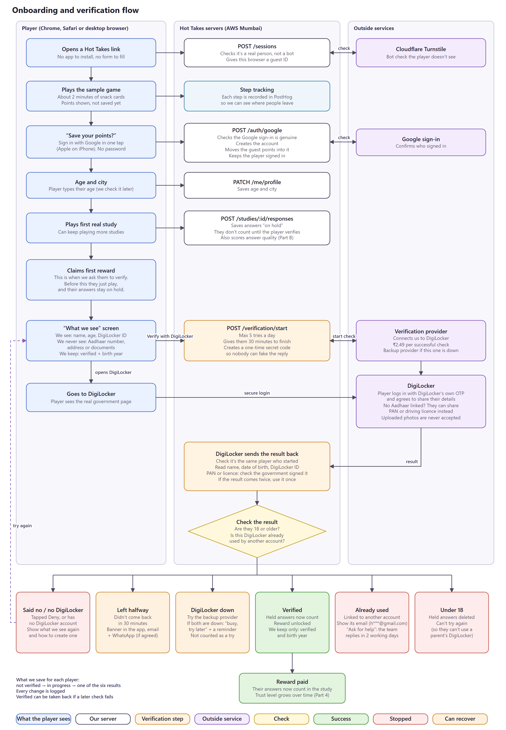
Onboarding and verification flow (editable: challenge2-onboarding-flow.drawio)

3. Recommended technical architecture
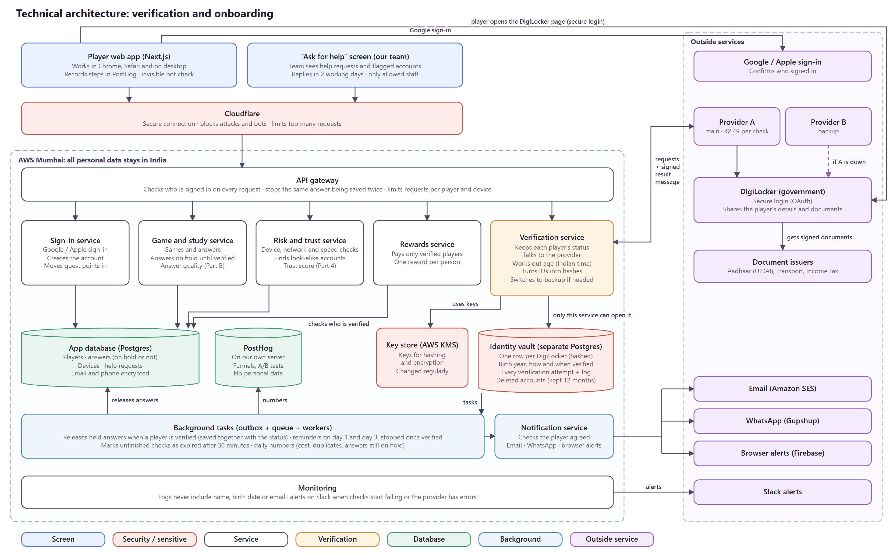
Technical architecture (editable: challenge2-architecture.drawio)
Main choices: the browser never decides anything, only the server does. Verification is its own service with its own locked database, and it's the only part of the system that can read identity data. We talk to DigiLocker through an aggregator behind our own adapter, with a second aggregator ready if the first fails. Everything that has to happen after a status change, like releasing held answers or sending reminders, goes through an outbox so it can't be lost. All personal data stays in AWS Mumbai.

4. Key APIs, backend logic and database considerations
APIs
Endpoint | Called by | What it does
/sessions POST | Browser | Starts an anonymous session, verifies the Turnstile token, stores a fingerprint hash
/auth/google POST | Browser | Verifies the Google ID token (signature with cached keys, audience, expiry), finds or creates the user by Google “sub”, links the anonymous ID, sets a signed HttpOnly, SameSite cookie
/me/profile PATCH | Browser | Saves typed age and city
/studies/:id/responses POST | Browser | Saves an answer with hold_state = held, or released if already verified. Needs an Idempotency-Key header so retries don't double-save
/me/verification GET | Browser | Current status, reason and tries left, which drives the banner
/verification/start POST | Browser | Checks the 5-a-day limit, creates a session (state, PKCE verifier, 30-minute expiry), calls provider.start() and returns the redirect URL
/verification/callback GET | DigiLocker redirect | Checks state against the session cookie, calls provider.getResult(), runs the decision logic below, redirects to the result screen
/webhooks/verification/:provider POST | Aggregator | Checks HMAC signature, timestamp (±5 min) and IP allow-list, then runs the same decision logic. Safe to receive twice
/support/cases POST | Browser | “Ask for help”, for example a disputed duplicate
/admin/review/:caseId POST | Team (Ask for help) | The team decides an “Ask for help” case. Access is time-limited and every action is logged
/me DELETE | Browser | Deletes the account; the DigiLocker hash moves to tombstones for 12 months

Provider adapter
All verification code talks to one interface, so switching aggregators or going direct to DigiLocker later means writing one new adapter:
interface VerificationProvider {
name: 'aggregatorA' | 'aggregatorB' | 'digilockerDirect';
start(s: { sessionId: string; state: string; codeChallenge: string;
redirectUri: string; scopes: ('profile' | 'issued_doc')[] }): Promise<{ redirectUrl: string }>;
getResult(r: { code: string; codeVerifier: string }): Promise<VerifiedClaims>;
parseWebhook(raw: Buffer, headers: Headers): WebhookEvent; // throws if the signature is bad
}
type VerifiedClaims = {
digilockerId: string; dob: string; eaadhaar: boolean;
issuedDoc?: { type: 'PAN' | 'DL'; number: string; dob: string; signatureValid: boolean };
};
A circuit breaker wraps each provider. It opens when more than 20% of calls fail within a minute (with at least 20 calls), sends traffic to the fallback, and tries the main provider again after 60 seconds.
Decision logic (callback and webhook share it)
handleResult(sessionId, claims):
BEGIN
s = SELECT * FROM verification_sessions WHERE id = $1 FOR UPDATE
IF s.status <> 'pending' THEN COMMIT; RETURN -- already handled: idempotent
dob = claims.eaadhaar ? claims.dob
: claims.issuedDoc?.signatureValid ? claims.issuedDoc.dob : NULL
IF dob IS NULL -> transition(s, 'failed', 'no_trusted_doc')
ELSIF ageIST(dob) < 18 -> transition(s, 'under_age'); lock user; outbox('delete_held')
ELSE
dl = hmac(key_v, claims.digilockerId)
doc = claims.issuedDoc ? hmac(key_v, type || number) : NULL
INSERT INTO identities (...) VALUES (...) -- unique indexes do the duplicate check
ON unique_violation -> transition(s, 'duplicate'); open review case
transition(s, 'verified'); outbox('release_held', user_id)
COMMIT
-- claims are dropped from memory here; nothing raw is logged or stored

ageIST(dob): today in Asia/Kolkata; years = today.year - dob.year
minus 1 if this year's birthday hasn't come yet
year-only dates are treated as 31 December of that year
Status transitions
From | To | When
unverified | pending | POST /verification/start
pending | verified | Adult, trusted birth date, identity not seen before
pending | failed (reason) | user_denied, no_account, no_trusted_doc
pending | expired | Expiry job: still pending after 30 minutes
pending | under_age | Under 18. Final, no retry
pending | duplicate → review | Unique index violation on digilocker_hmac or doc_hmac
failed / expired | pending | Player retries (within 5 a day per account and device)
review | verified / failed | Team decision, logged
verified | revoked | A later re-check returns a different identity, or fraud is confirmed

Every transition goes through one function that checks the move is allowed, bumps a version number (so two updates can't clash) and writes a row to verification_events. provider_error is not a status; the session stays pending while we fail over.
Database
Two Postgres databases. The identity vault belongs to the verification service alone; the rest of the app can only ask whether a user is verified and their age band.
-- IDENTITY VAULT (only the verification service's DB role can connect)
CREATE TABLE identities (
identity_id uuid PRIMARY KEY,
user_id uuid NOT NULL UNIQUE,
digilocker_hmac bytea NOT NULL,
doc_type text, -- 'PAN' | 'DL', only on the non-Aadhaar route
doc_hmac bytea,
name_dob_hmac bytea, -- soft match, flags only
birth_year smallint NOT NULL,
method text NOT NULL CHECK (method IN ('eaadhaar','pan','dl')),
key_version smallint NOT NULL,
verified_at timestamptz NOT NULL
);
CREATE UNIQUE INDEX ON identities (digilocker_hmac);
CREATE UNIQUE INDEX ON identities (doc_type, doc_hmac) WHERE doc_hmac IS NOT NULL;
CREATE INDEX ON identities (name_dob_hmac);

CREATE TABLE verification_sessions (
id uuid PRIMARY KEY, user_id uuid NOT NULL, provider text NOT NULL,
state_hash bytea NOT NULL, pkce_verifier_enc bytea NOT NULL,
status text NOT NULL, reason text, attempts_today smallint,
version int NOT NULL DEFAULT 0,
created_at timestamptz NOT NULL, expires_at timestamptz NOT NULL, completed_at timestamptz
);
CREATE INDEX ON verification_sessions (status, expires_at); -- expiry job
-- verification_events: append-only, partitioned by month
-- tombstones (digilocker_hmac, expires_at)
-- outbox (id bigserial, topic, payload jsonb, created_at, processed_at)

-- APP DATABASE
ALTER TABLE responses ADD COLUMN hold_state text NOT NULL DEFAULT 'held'
CHECK (hold_state IN ('held','released','deleted'));
CREATE INDEX ON responses (user_id) WHERE hold_state = 'held';
- Why HMAC: the key lives in KMS, not the database, so a leaked database can't be matched against any other list. Each row records key_version, so the key can be rotated; during a rotation, lookups check both versions.
- Why the database enforces duplicates: the unique index means two sign-ups with the same identity at the same moment can't both get through, whatever the code does.
- What's never stored: full birth date, name, gender, documents and Aadhaar numbers. Email and phone are field-encrypted in the app database.
Background jobs
Job | Runs | What it does
Task runner | All the time | A player's verified status and their answers are in two separate databases, so we can't update both at once. We save a “release answers” task together with the verified status, and this job runs it, again if needed after a crash, so answers never get stuck on hold.
Release held answers | When a player is verified | Answers from real studies the player played before verifying are on hold. Once they're verified, this marks all of them as counted, so they become part of the study.
Expiry | Every 5 min | Pending sessions past expires_at: asks the provider for the result once, then marks them expired
Reminders | Day 1 and day 3 | Email, plus WhatsApp if opted in. Cancelled the moment the player verifies
Retention | Nightly | Deletes sessions older than 90 days, held answers older than 90 days, and expired tombstones
Metrics | Daily | Pushes check costs, duplicates and unreleased answers to PostHog

5. Potential failure scenarios and how I'd handle them
The player-side cases are also in my Challenge 2 notes (sections 2 and 3). Here they're together with the system and fraud cases.
Scenario | How we spot it | How we handle it
Player side
Leaves DigiLocker midway | No callback or webhook within 30 minutes | expired → banner, email on day 1 and day 3, WhatsApp if opted in. “Continue” starts a fresh session; games and points are safe
Taps Deny | Provider returns access_denied | failed (user_denied) → show again what we see, retry any time
No DigiLocker, or no trusted document | Reason code | Short setup guide, then the same reminders
Under 18 | Server age calculation | under_age, final. Held answers deleted, account locked from verifying again
Identity already linked | Unique index violation | Show the masked email of that account; “Ask for help” goes to review within 2 working days
System side
Aggregator down or slow | Error rate and timeouts trip the circuit breaker | Switch to the fallback aggregator. Not counted as a try. Slack alert
DigiLocker itself down | Both aggregators fail the same way | Player sees “DigiLocker is busy”, reminders take over
Callback never arrives (tab closed) | Session still pending | The webhook completes it. If neither arrives, the expiry job asks the provider once before marking it expired
Callback and webhook both arrive | Same session ID | Row lock + status check: the second one does nothing
Same identity on two accounts at once | Unique index | One insert wins, the other becomes duplicate
Token swap fails | Error on the code exchange | Codes work once, so no blind retry. Restart the flow, not counted as a try
Forged or replayed callback / webhook | State mismatch, bad HMAC, old timestamp, unknown IP | Rejected and logged as a security event
Tampered issued document | Issuer signature check fails | signature_invalid → review
Worker crashes while releasing answers | Outbox row not processed | Retried automatically. The release update is idempotent
HMAC key exposed | Incident or scheduled rotation | New key_version, lookups check both during rotation, old key retired
Fraud side
Using a family member's DigiLocker | name_dob match, shared device, look-alike behaviour | Review. A re-check must return the same identity
Many Google accounts | Fingerprint and IP clusters, sign-up bursts | Worthless without a real DigiLocker each. Rate limits and review
Verified account sold or taken over | New device + payout change before a reward | Fresh DigiLocker check that must match the stored hash
Honest family flagged | High false-alarm rate in review results | Flags never block. Loosen the device rule
Data
Database breach | Anomaly alerts | The vault holds only hashes and birth years. Breach plan: notify the Data Protection Board and users
Held answers never released | Older than 90 days | Deleted, and tracked as a metric

6. Metrics I'd track to measure success
Already covered in section 5 of my Challenge 2 notes: 15 metrics across signup, verification, drop-offs, duplicates and time to first participation, tracked with PostHog events and reviewed weekly.

